A graph (G) is an ordered pair which contains a set of vertices represented as V and a set of edges represented as E, each edge is associated with one or two vertices known as endpoints .A graph is checked whether it is a directed graph i.e. if the edges of the graph is associated with ordered pair of vertices. If the graph is directed then it is checked whether it is strongly connected or not. If all the pairs of vertices contains a path then the graph G is said to be strongly connected graph. The degree of the graph G is then calculated by adding the degree of all the vertices of the graph, degree of vertex is the number of edges that clashes on the vertex. Here , the finite complete bipartite graph is taken for the focal landscape as all the patches of the landscape are bipartite in nature , i.e. the vertices of the area are divided into disjoint sets A,B,C,D( as shown below) such that every edge connects a vertex one set connecting one in all of the sets .

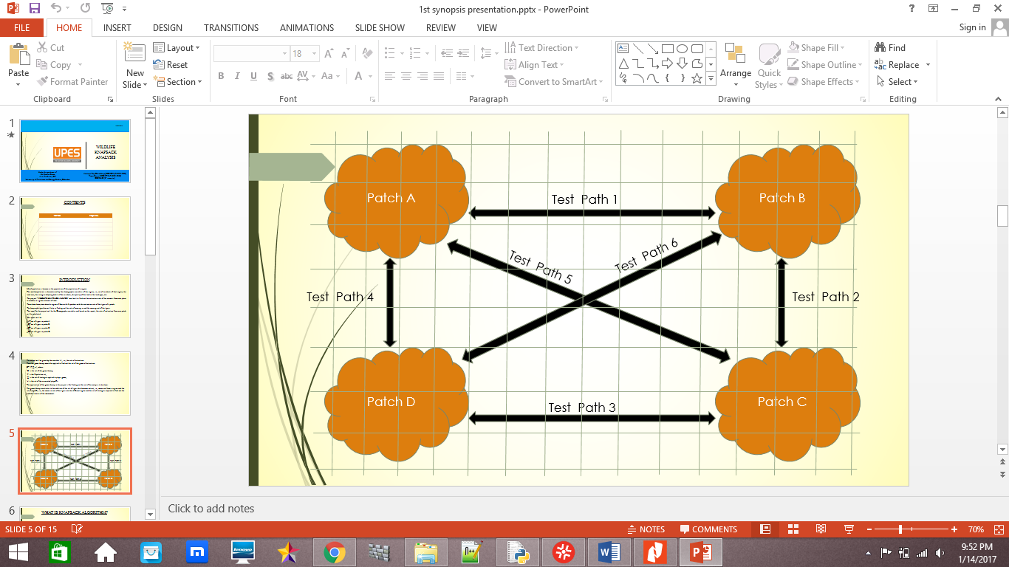

Fig 1.1: A diagrammatic representation of the proposed biogeography.

*T* is a connected a graph. If the vertex of the tree has exact one degree then it is the leaf of the tree. If the vertex has no path from vertex to vertex then it is the root of the graph. A tree *T is not a spanning tree if it doesn’t contain a connected graph. The graph contains V-1 edges.*

The Centrality measures assign real values to the vertices or edges and rank them accordingly. The result of a centrality measure depends on

the structure of the graph.

We use the degree centrality , eigenvector centrality , betweenness centrality , closeness centrality , subgraph centrality , positively-scaled subgraph centrality ,and negatively-rescaled subgraph centrality for analysis of the ranking of the grids on the basis of their respective scores. A brief description of each centrality measure given below:-

**Degree centrality:** The degree centrality of a vertex [9] is the number of edges incident to it. In formal notation, degree centrality of a vertex 𝑣,

𝐷(𝑣) = deg V

Here, high degree of a habitat patch shows higher rate of individual flux rate through the vertex as vertices having higher degree of centrality provide higher number of alternative ways to the individuals.

**Eigenvector centrality :**

Here the eigenvector centrality helps to determine those vertices which themselves doesn’t have high number of pathways incident to it but , are important because of their neighboring patches which do.

**Betweenness centrality :**

Habitat patches with high betweenness centrality measure shows those vertices which often act as a bridge between patches. Betweenness centrality is important as bridges are the means of travel for the species.

**Closeness centrality :**

Closeness centrality measure shows vertices which are nearest to most other vertices(distance-wise) as it lists out the vertices which can communicate to each other quickly. This can improve the efficiency for travel distance and can be advantageous in case of epidemic and human settlements for construction to reduce the frequency of conflict between human and species.

**Subgraph centrality :**

A High value of subgraph centrality shows that species can move from that patch to many number of other patches and then return, by using predominantly closed paths of shorter lengths. It is efficient for the round trip and energy management.

**Rescaled subgraph centralities:**

A high value of rescaled subgraph centralities allow the individuals to determine the patches from which they would be able to migrate to many number of patches and return by shorter closed paths or longer closed paths.

**Detecting community structure:**

It helps to identify the communities which could help to understand the behavior of the behavior of the species and the patterns of their travel.

**Edge-betweenness centrality:**

High edge-betweenness centrality shows pathways which act as a bridge between patches, not adjacent otherwise.